**TECHNICAL UNIVERSITY – SOFIA**

**PLOVDIV BRANCH**

**FACULTY OF ELECTRONICS AND AUTOMATION**

**FINAL YEAR PROJECT**

**BACHELOR'S DEGREE**

**TITLE:**

**A software system for automatically selecting suitable candidates according to their qualifications**

**STUDENT:Lubomir Lambrev**

**SUPERVISOR:**

**PLOVDIV 2018**

**DECLARATION OF ORIGINALITY OF THE FINAL YEAR PROJECT**

I, the undersigned Lubomir Lambrev**,** a student in the Industrial Engineering degree course in the Faculty of Electronics and Automation at the Technical University of Sofia, Plovdiv Branch, graduating during the 2021/2022academic year,

faculty No: 510259

declare that the foregoing implementation of the specific tasks related to my final year project, entitled: A software system for Automatically selecting suitable candidates according to their qualifications

with supervisor:

in the volume of ....... text pages and .......... pages with annexes, including number of figures: .........., number of tables: ..........., is the result of my own work.

#### Date::..................... Signature: ..........................................

**A REVIEW OF THE FINAL YEAR PROJECT BY THE SUPERVISOR**

The final year project is performed according to the assignment in full volume **/** in the volume of % (please underline the correctanswer and if the implementation is less than 100 **% ,** a motivation should be filled in and it is mandatory required upon admission to the presentation of a final year project)

and may **/** may not be admitted to presentation.

#### Motivation:......................................................................................................................... ….......................................................................................................................................

Signature: **................................**

#### (Supervisor)

#### Selected reviewer:............................................................................................................

Signature: ................................

(Head of Department)

**Table of Contents**

**References**

**A software system for automatically selecting suitable candidates according to their qualifications**

**1. Introduction**

In this work, an application is developed to allocate the most suitable applicants to certain positions. The selection is made on the basis of the highest score presented qualifications and skills of the applicant.

A program must be written to find the best arrangement for each applicant and the corresponding workplace.

The list of jobs is provided by the employer, and the list of applicants by the employment agency. We will consider evaluating each applicant's qualification (competence) as the number of years of experience of the applicant.

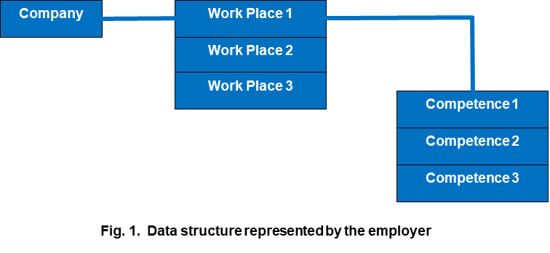

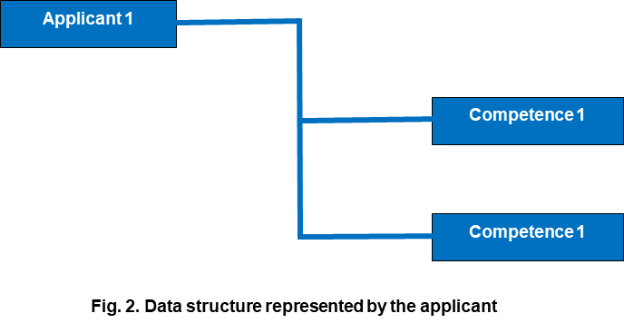

**Fitting function** – Determines to what extent a give competence is covered by the applicant.

The fitting function brings back a numerical value (metric, grade)

For that reason, there are 3 outcomes:

1. When the competence is required by the employer and possessed by the applicant (we return the number of years of the applicant).
2. When the competence is required by the employer, but the applicant does not have such a qualification, we return 0.
3. When the applicant has a qualification that is not required at the work place, we return 0.

It is important to return 0 and not NaN or None so that we can sum later in the other functions.

**Utility function** - This function returns the sum of all fitting values of the ordered pair (Applicant, Workplace) --> utility_value.

**general utility function** returns--> general_utility_value.

The ordinance is a way of describing the relationship between the workplace and the applicants.

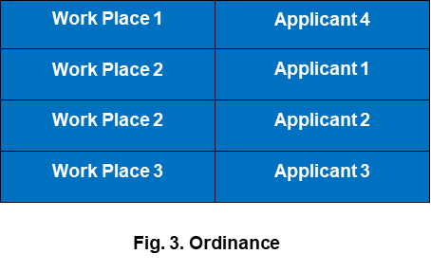

Algorithm of full enumeration:

1. We load the list of Workplaces.
2. We load the list of Applicants.
3. We create a list of all possible ordinances.
4. We calculate the general_utility_value for each item in this list.
5. We find the max general_utility_value from this list.

This is the so-called naive approach or the method of full enumeration

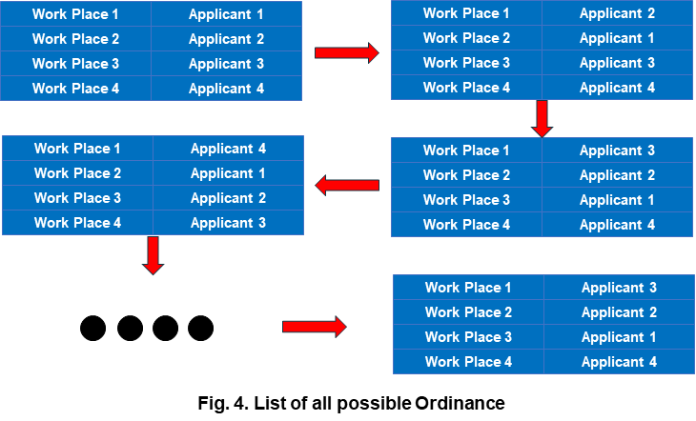

Conceptual model

A conceptual model of a system is an abstract description of what that system is supposed to do.

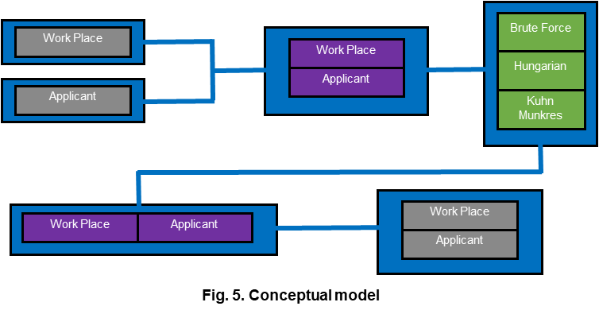

Gray- Files

Purple- Objects, Structure

Green- Algorithms

Scenario for the system

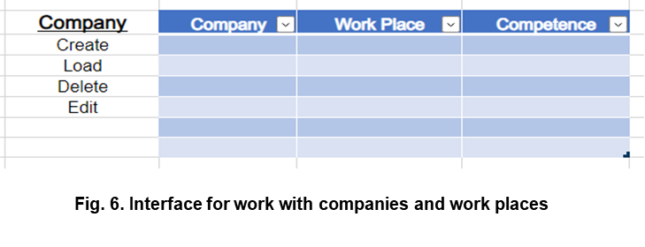

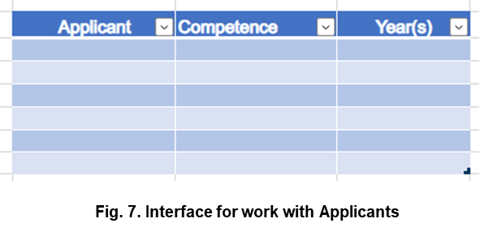

Example assignment

A competition has been announced by company 1 (C-1) with three jobs. Each job has a set of 2 to 5 competences

For example:

Competence 1,2,5 is required for job 1. Three applicants appear, each of them having from 1 to 5 competence (these candidates have passed preliminary selection so that each of them has the permissible competence). We make the necessary permutations.

For each element of the permutation, we calculate the total sum of competence. The item with the max amount is the one we are looking for.

Research

There will be a Jupyter Notebook with the performance comparison of the two algorithms.

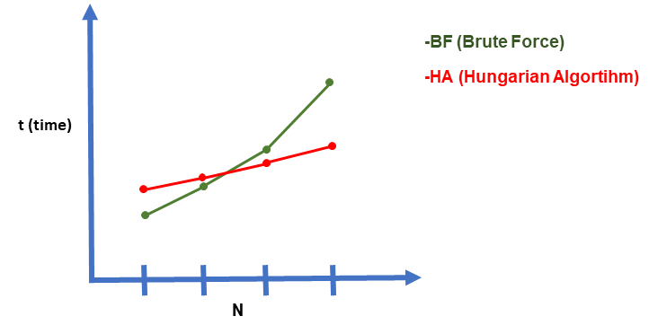  
For the competition NxN --> N – Work Places

N - Applicants.

# How Can Automation Help Alleviate Labor Shortages?

[<https://www.globaltrademag.com/how-can-automation-help-alleviate-labor-shortages/>]

Labor shortages are often discussed in fields such as logistics, but a growing number of industries have more job openings than people to fill them. Manufacturing, education, health services and retail are many industries struggling to bring in new hires and retain existing employees.

Automation and robotics may have a negative reputation for stealing people’s jobs, but in almost every case, it supplements floundering workforces. Here’s how it can help alleviate labor shortages in various industries and help bolster the economy.

**Labor Shortage Statistics**

Looking at any industry from the outside, it might seem like everything is working as it’s meant to. However, behind the scenes, the problem becomes glaringly apparent. Foodservice and hospitality-related businesses experienced a 6.6% quit rate in September 2021.

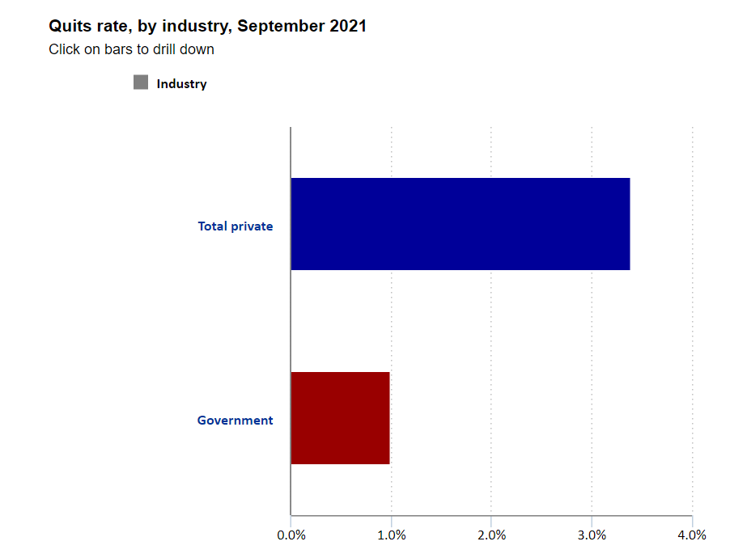

Statistic-[https://www.bls.gov/opub/ted/2021/quits-rate-6-6-percent-in-accommodation-and-food-services-in-september-2021.htm]

Durable goods manufacturing is seeing even worse resignation levels. Companies are struggling to hire enough workers to fill vacant positions and stay ahead of the competition.

Industries worldwide have lost millions of workers due to COVID-19 and the Great Resignation that followed. Many of those who left the workforce during the pandemic decided that taking early retirement was a better option than returning to work once things returned to normal. The best choice for employers would be to make the necessary changes to bring in new workers and retain those already employed. However, automation may be able to help fill in some of the gaps.

**Freeing up Skilled Workers for Critical Tasks**

Most industries have many mundane or repetitive tasks that are necessary to complete the job. They are all necessary, but thanks to automation, they do not need to take up the time or skills of an employee better suited to more complex or critical work. Relegating these mundane or repetitive tasks to robotics or automation services can also help reduce the number of repetitive stress injuries in the workplace. Poor posture, repeated motions and other repetitive movements can cause injuries which, in turn, can lead to missed work and workers’ compensation claims. Widespread use of automation and material handling solutions could help reduce those numbers dramatically.

## Benefits of an automated recruitment system

[<https://recruitee.com/articles/automated-recruitment-system#2>]

As you can probably picture, automating your most repetitive and time-consuming tasks brings benefits for your overall recruitment system. Here are just some of the primary benefits from implementing an automated recruitment system.

**Avoid bottlenecks in the recruitment pipeline**

By automating your most common tasks, you can ensure that you never have a backlog of work sitting on a team members’ desk, holding up the entire hiring process. This is especially important if you work as a recruiter for a high-turnover industry such as call centers. One of the primary factors that contribute to inefficient recruitment funnels, and lost opportunities to hire top talent, is lengthy delays in moving applicants through the pipeline.

Automation can help prevent these situations by ensuring that all of the most important, but simple, tasks aren’t piling up somewhere. Instead, candidates are able to move smoothly through the pipeline, and recruiters are able to easily meet deadlines and make decisions on who to hire.

Some of the ways that an automated recruitment system can help you avoid bottlenecks include:

* Filtering applicants quickly
* Avoiding overloading
* Notifying team immediately when actions need to be taken
* Automatically flagging at-risk deadlines

Together, these automated actions can help to ensure that your recruitment funnel is always running smoothly. Which brings us to the second benefit.

### **Eliminate time and waste**

Eliminating bottlenecks and improving the overall efficiency of your pipeline helps to eliminate time and resource waste that can lead to the overall poor performance of your recruitment process. Delays and missed steps due to task overload can cause lost productivity and revenue by failing to fill a skills gap when it’s needed.

Additionally, sourcing and screening candidates takes both monetary and human resources, both of which can be very expensive for the organization. Wasting that money and effort due to a lack of automation, or because of task overload, is simply not a good business move for your company.

Some examples of how automation can help to eliminate time and waste include:

* Eliminating the need to manually call non-responsive or unqualified candidates
* Freeing recruiters from repeating the same task over and over again
* Automatically identifying areas of inefficiency and waste

By automating the most time-consuming tasks, and continuously monitoring the efficiency of your recruitment process, you can drastically reduce the amount of costly waste at your company.

### **Focus your time on top talent**

A recruiter’s job should mostly focus on finding and engaging with high potential applicants who will make a real difference at the organization. Implementing an automated recruitment system will allow your recruiters to focus on doing just that, rather than tasks that don’t really move the dial for your organization.

**Reactivate candidates to fill your talent pipeline**

Automated recruitment systems are able to regularly, at scheduled times, scrape your existing database for qualified candidates who fit the bill for a current or future job opening. Once reactivated, these passive candidates can then be engaged either by automated communications, or directly from a recruiter.

**Improve applicant experience**

An automated recruitment system that eliminates bottlenecks, delays, and missed communications contributes to an overall better candidate experience for your applicants. If there’s one thing that can ruin a applicants’ opinion of your organization it’s poor communication, and not following through on what you say you’re going to do.

By ensuring that all of the crucial touch points are covered, automated actions can ensure that every applicant, no matter what the outcome, receives a solid candidate experience. And of course, maintaining a great candidate experience also contributes to a great employer brand, which is critical to attracting top talent to your team.

**Improve quality of hire**

Naturally, each of the benefits above will ultimately contribute to better hiring results overall. An automated and systematic approach to hiring that’s driven by analytics and continuous improvement means that you and your recruitment team can continuously hone your recruitment process.

As you continue to audit and improve your process, the overall efficiency and quality of your decision making will also continue to elevate to the next level. The end result is, ultimately, hiring better people, more frequently, with less effort than you had to put in before.

**Increase workforce diversity**

Automated recruitment systems help to eliminate much of this inherent human bias. Rather than relying on a subjective reading of a resume to determine if a candidate moves on to the next round, for example, automation can make that decision for you without any inherent bias. This can be extrapolated out too many different critical touch points in the recruitment funnel that may be affected by bias.

As you can see, recruitment automation systems carry with them a wide range of benefits and use cases that should be of interest to most recruitment teams. If you’re considering adopting automation into your recruitment process, the best place to start is by looking at where your team is spending most of their time, and which tasks they’re least excited to do. More often than not, these will be tasks that a machine could happily take off their hands.